15.13: a)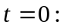
____________________________________________________________
x(cm) 0.00 1.50 3.00 4.50 6.00 7.50 9.00 10.50 12.00
____________________________________________________________
y(cm) 0.000 −0.212 −0.300 −0.212 0.000 0.212 0.300 0.212 0.000
____________________________________________________________

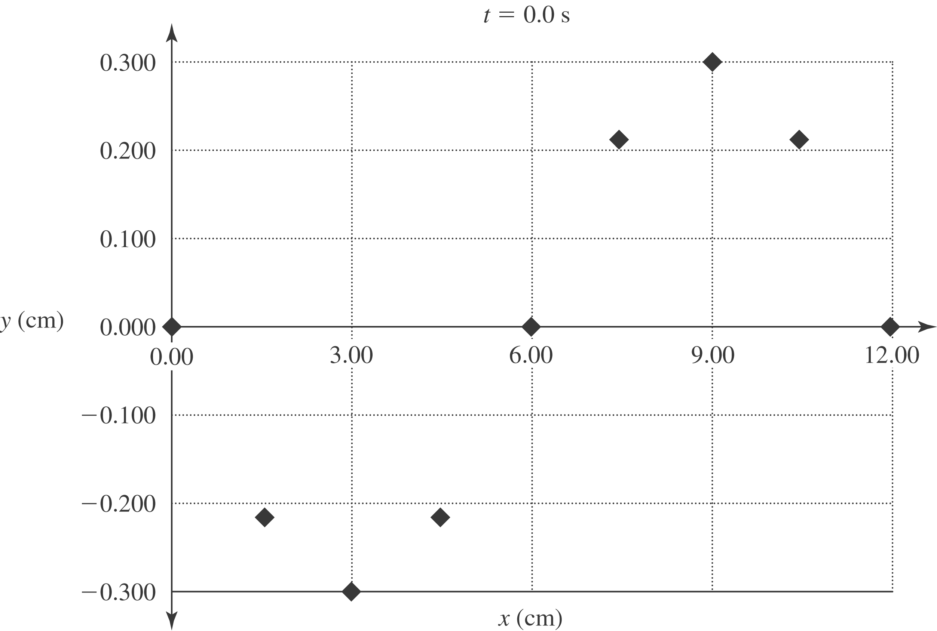
b) i) t = 0.400 s:
_______________________________________________________________
x(cm) 0.00 1.50 3.00 4.50 6.00 7.50 9.00 10.50 12.00
_______________________________________________________________
y(cm) 0.285 0.136 −0.093 −0.267 −0.285 −0.136 0.093 0.267 0.285
_______________________________________________________________

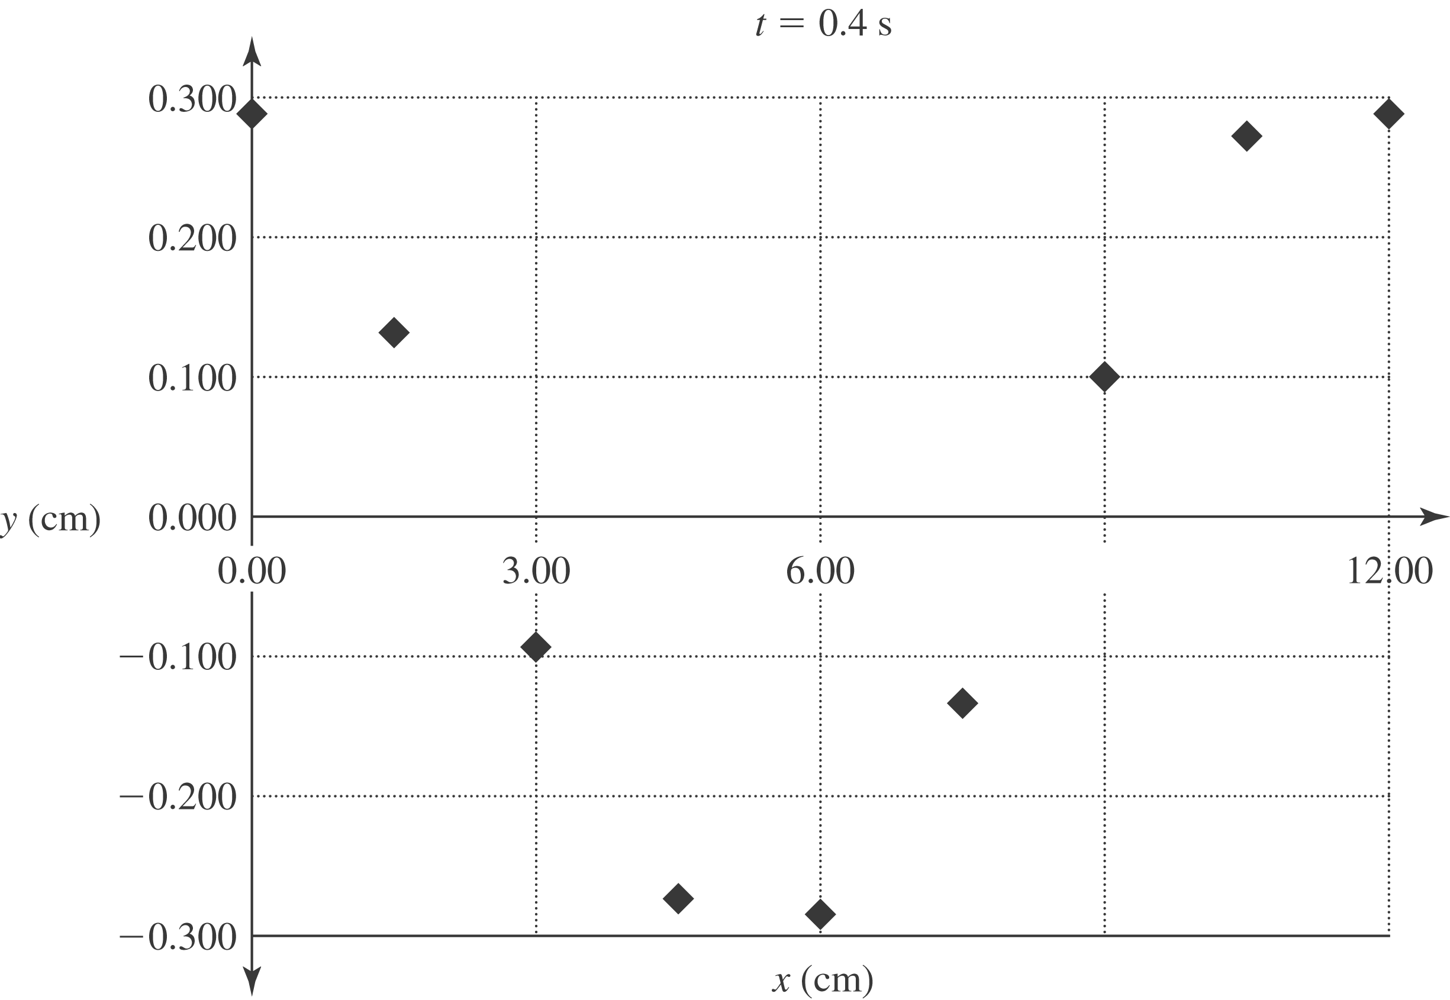
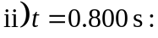
________________________________________________________________
x(cm) 0.00 1.50 3.00 4.50 6.00 7.50 9.00 10.50 12.00
________________________________________________________________
y(cm) 0.176 0.296 0.243 0.047 −0.176 −0.296 −0.243 −0.047 0.176
________________________________________________________________

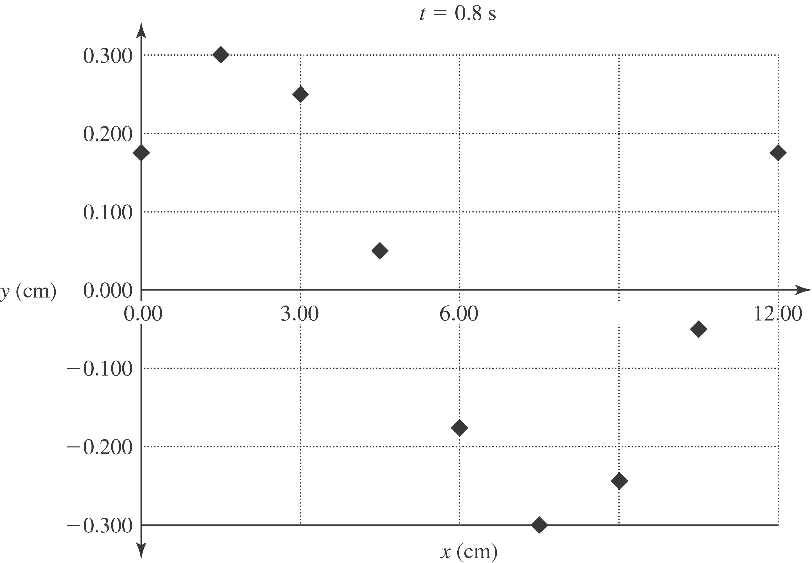

iii) The wave is traveling in 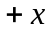-direction.

